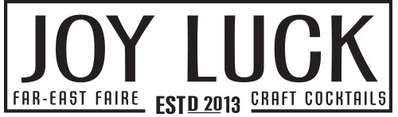

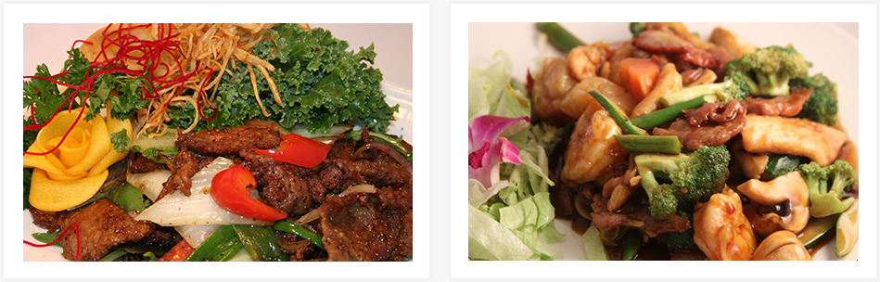

THE JOY LUCK

At The Joy Luck, we are all about wholesome, belly-warming comfort food in a friendly and cozy atmosphere. Our philosophy is simple and honest, and we don't rely on pretenses. Good food, good drinks and good company.   
We would love for you to join us! Make it your lucky night at The Joy Luck.

- OPENING HOURS -

Monday : 5pm-11pm  
Tuesday - Wednesday : 11am-10pm  
Thursday - Saturday : 11am-11pm  
Sunday : 11am-10pm

http://www.thejoyluck.com/img/divider.jpg

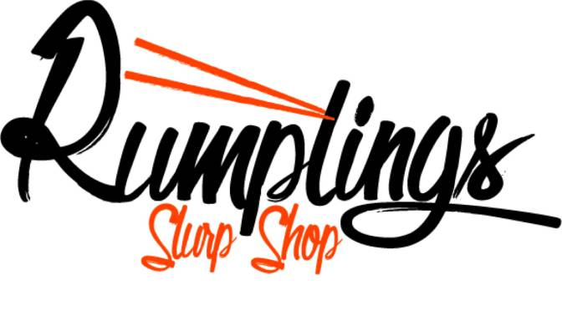

[**HIGHLANDS NEIGHBORHOOD NEWS**](http://highlandshomeplace.com/category/highlands-neighborhood-news/)**,**[**HIGHLANDS RESTAURANTS**](http://highlandshomeplace.com/category/highlands-restaurants/)

RUMPLINGS: AUTHENTIC RAMEN AND HOMEMADE DUMPLINGS

[Louisville’s first authentic noodle shop](http://highlandshomeplace.com/2014/10/02/noodles-and-dumplings-coming-to-the-highlands/), located on Highland Ave formerly known as Baby D’s Bagel and Deli.

Authentic ramen includes homemade wheat noodles, broth, different proteins, veggies, and any combination thereof. There are some standards when it comes to ramen like salt, pork, miso, and soy; and you can expect to see some of these on the Rumplings menu. However, these guys know what they’re doing. Creativity is part of the deal, so expect some really cool dishes with a lot of local flare.

The menu will remain relatively small and change frequently. Homemade noodles, homemade dumplings, homemade broth, all local produce, indigenous ingredients, and the list goes on.

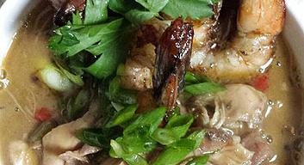

ROUX

#### ix of culture and music stems from its Fr

#### New Orleans eclectic mix of culture and music stems from its French, African, Creole and Spanish roots. This diversity helped pave the way for the completely unique cuisine, music and architecture that so distinctly differentiates New Orleans from most major American metropolitan areas.

OPENING HOURS

**Monday - Sunday**  
**Beignet Window***cash only* 9:30am - close  
**-**

**Lunch**

Mon - Fri • 11am - 5pm  
**-**

**Dinner**

Mon - Sat • 5pm - 11pm

Sunday Menu • 4pm - 11pm

**-**

**Saturday & Sunday Brunch**

Sat: 11am - 5pm

Sun: 10am - 4pm

**-**

**Bar open late** on Fri - Sat

Live Jazz Thurs: 6-10pm

Fri & Sat: 9-1am

ADDRESS

1325 Bardstown Road

Louisville, Kentucky 40204

Holy Grale

Good beer and good company is the only thing we pray for in this house of worship.  Built in 1905, this small Unitarian Church in the heart of the Louisville’s Original Highlands neighborhood is now home to the Holy Grale. Here you can come taste a variety of ever-changing beers from all over the world poured from one of our 26 taps, or opt for our bottle list.

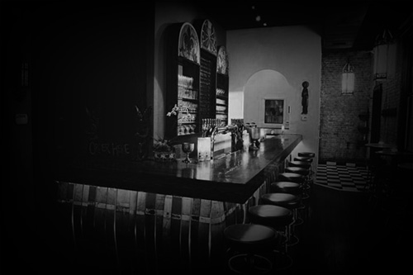

To accompany, we proudly serve seasonally inspired menu created by Chef Joshua Lehman, sous chef Paul Skulas and team (Pete Thompson, Chris Hamilton and Alison Settle) using only the highest quality ingredients sourced from local farms and producers

*Holy Grale is proud to be a Kentucky Proud Member and support the following local farms and :* 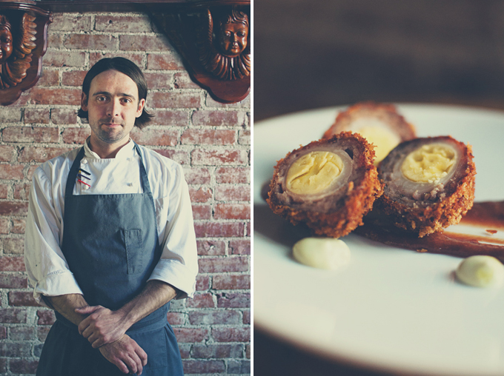

If you are looking for bourbon or wine only, beware, you will find none here… so come with an open mind and we promise to help you find the perfect beer! Please note that Holy Grale has very limited seating and is available on a first come first serve basis only.

EIDERDOWN

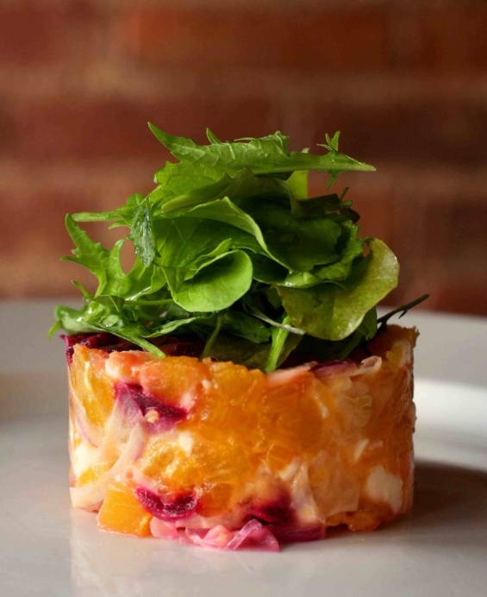

IS NOT A GERMAN RESTAURANT.

For some, "German food" may conjure images of schnitzel with thick gravy, cabbage and naps. For us, "German food" is one of our many inspirations, but not the sole basis of what we do.

WHAT WE DO IS CREATE FRESHLY PREPARED FOOD: MODERN VARIATIONS ON CLASSIC FLAVORS USING TRADITIONAL FRENCH METHODS. MOST OF OUR MEATS AND CHEESES ARE FROM INDEPENDENT KENTUCKY AND INDIANA FARMERS AND OUR PRODUCE — LIKE OUR MENU — IS APPROPRIATE TO EACH SEASON.

Another inspiration is beer. Without it, Eiderdown may not have been conceived or actualized. With our 21 draft beers, we aspire to cover a broad range of stylistic bases, offer several esoteric choices in imported and craft beers and also be able to place a bottle of Stroh's in the hand of someone who wants to pour a Stroh's into his or her mouth. We follow a similar ethos in choosing our wine list.

As for the German association, we are proudly located in the Germantown neighborhood in Louisville, Kentucky. "Eiderdown" may sound Germanic, but it is not. We also serve a handful of great German beers and Austrian wines, but that's because we are huge fans of the way they taste and how they taste with our food.

And ultimately, food is what Eiderdown is about. We hope the liberties we take with it evoke a sense of freedom in each of our guests and that your visits with us are confounding, cohesive and commendable. With that in mind, feel free to categorize us any way you like; European-inspired Southern food is what we had in mind...

, it became extremely apparent to him that his heart was entrenched in Creole Cuisine.

In September of 2014, that passion and love for New Orleans became a restaurant in our great city of Louisville named, "Roux." At Roux, we strive to

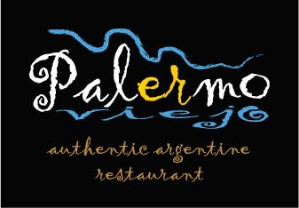

Palermo Viejo is the only authentic Argentine restaurant in 3 states & features the only Argentine charcoal grill in the Midwest. Palermo Viejo specializes in free-range beef, handmade pasta & Argentine wines.

